
ASTRAQUANTUM TECH
SUMMER OF CYBERSECURITY 2026
WEEK 7 - SOC / BLUE TEAM ASSESSMENT
Logging • Monitoring • Log Analysis • Alert Investigation • Incident Response
Student Name | Muhammad Raza
Date | September 26, 2026
Instructor | AstraQuantum Tech Team
Program | Summer of Cybersecurity 2026

Table of Contents
1. Executive Summary 3
2. Scope & Authorized Environment 3
3. Tools / Platforms Used 3
4. Learning Summary for Each Lab 4
Task A - TryHackMe SOC Fundamentals 4
Task B - TryHackMe SOC L1 Alert Triage 5
Task C - Blue Team Labs Online (D3FEND) 6
5. Alert Investigation 7
6. 5 Ws Analysis 8
7. Incident Timeline 8
8. Evidence & Screenshots 9
9. Verdict / Severity 9
10. Impact 9
11. Recommended Response 9
12. Conclusion 10
13. Appendix 10

1. Executive Summary
This report documents the completion of the Week 7 SOC / Blue Team practical assessment. Task A (TryHackMe - SOC Fundamentals) and Task B (TryHackMe - SOC L1 Alert Triage) were both completed to 100%, covering SOC roles, the People/Process/Technology model, alert triage methodology, and a hands-on L1 investigation of a benign port-scanning alert. Task C was completed using the Blue Team Labs Online D3FEND challenge, mapping defensive cybersecurity techniques to the MITRE ATT&CK framework.
For Task E/F/G, a phishing-driven intrusion alert was selected and investigated end-to-end as a junior SOC analyst: a user on workstation DESKTOP-WKSTN-04 executed a disguised executable (invoice.pdf.exe) delivered via a spoofed-vendor phishing email, which spawned an obfuscated PowerShell process and beaconed to an external IP. The alert was triaged using the 5 Ws, correlated across email gateway, Sysmon/EDR, and firewall/proxy logs, and confirmed as a True Positive requiring immediate containment and Tier 2 escalation.

2. Scope & Authorized Environment
All practical work was performed exclusively within the authorized training environments listed below. No real organizations, production systems, or public infrastructure were investigated at any point.
- TryHackMe - SOC Fundamentals (https://tryhackme.com/room/socfundamentals)
- TryHackMe - SOC L1 Alert Triage (https://tryhackme.com/room/socl1alerttriage)
- Blue Team Labs Online — D3FEND challenge (free challenge, defensive/threat-intelligence mapping)
- The phishing/PowerShell incident analyzed in Sections 5–7 and 9–11 is drawn from the simulated alert data produced by the SOC L1 Alert Triage lab environment, not a real host or account.

3. Tools / Platforms Used
Platform / Tool | Purpose
TryHackMe SOC Fundamentals room | Learning SOC roles, People/Process/Technology, detection vs. response, and a practical port-scan alert triage exercise
TryHackMe SOC L1 Alert Triage room | Practicing the event → alert → investigation → verdict workflow and closing simulated SOC dashboard alerts
Blue Team Labs Online (D3FEND challenge) | Researching the MITRE D3FEND defensive-technique catalog and its mapping to ATT&CK / Azure Sentinel
Sysmon (Event ID 1 & 3) | Process-creation and network-connection telemetry used to trace the phishing payload's execution chain
EDR / SIEM console | Alert generation, process isolation, and the source of the structured log analysis in this report
Email Gateway & Firewall/Proxy logs | Confirming phishing delivery and outbound C2 connection respectively

4. Learning Summary for Each Lab

Task A - TryHackMe SOC Fundamentals
Room / URL: SOC Fundamentals - https://tryhackme.com/room/socfundamentals (completed 100%)
L1 SOC Analyst Summary
A Tier 1 (L1) SOC Analyst serves as the frontline defender within a Security Operations Center. Their primary responsibility is to continuously monitor the influx of security alerts generated by SIEM (Security Information and Event Management) platforms, intrusion detection systems, and endpoint agents. When an alert triggers, the L1 analyst performs the initial triage to determine its validity, separating genuine security incidents (true positives) from benign network anomalies or authorized activities (false positives). This rapid investigation involves gathering initial context, correlating raw logs, checking threat intelligence feeds, and systematically answering the “5 Ws” (Who, What, When, Where, Why). If an alert is deemed a false positive, the analyst documents the justification and closes the ticket to reduce alert fatigue. If the alert is a true positive or requires complex forensic analysis, the L1 analyst packages the gathered evidence, recommends initial containment steps, and escalates the ticket to a Tier 2 (L2) incident responder. Ultimately, they act as the critical filter ensuring the SOC operates efficiently.
Practical Alert - 5 Ws Analysis (Port Scan)
- What: A Port Scan activity triggered the security alert.
- When: The scanning activity took place on June 12, 2024, at 17:24.
- Where: The scan was directed at the destination host IP 10.0.0.3.
- Who: The source of the scan was identified as the vulnerability scanner tool Nessus, originating from host 10.0.0.8.
- Why: This activity was intended and benign. The vulnerability assessment team had proactively notified the SOC team that they would be running authorized port scanning activities inside the network from that specific host.
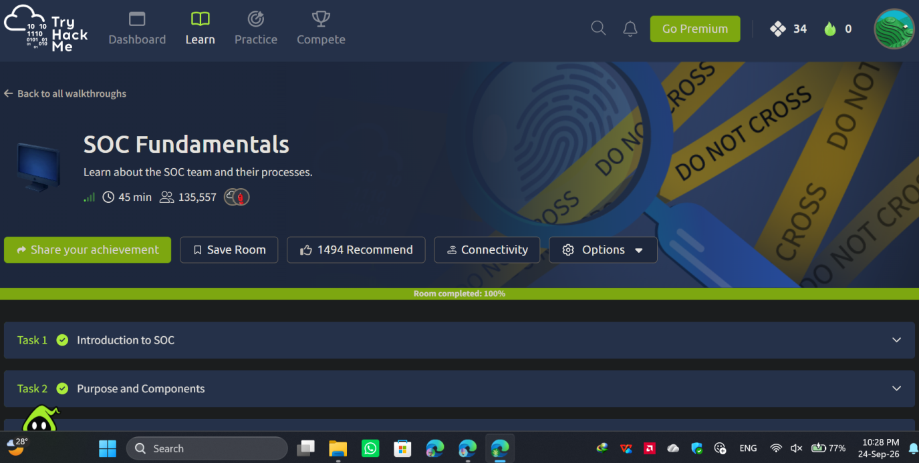
Figure 1 - TryHackMe SOC Fundamentals room completion verified.
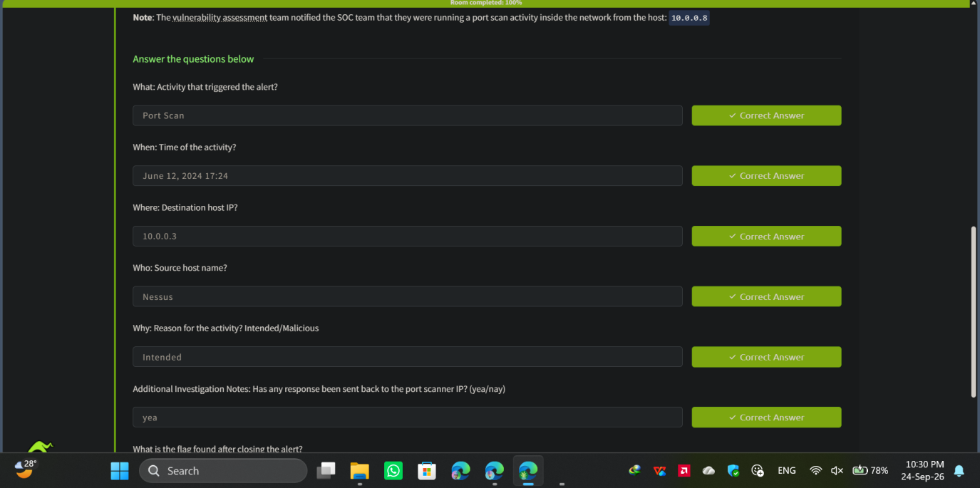
Figure 2 - Practical alert triage exercise confirming the 5 Ws of a benign port scan.

Task B - TryHackMe SOC L1 Alert Triage
Room / URL: SOC L1 Alert Triage - https://tryhackme.com/room/socl1alerttriage (completed 100%)
Alert Triage Flow
The systematic approach to handling an alert ensures that nothing is overlooked and efforts are not duplicated across the SOC team. The triage flow proceeds as follows:
- New: The alert is generated by the SIEM or IDS and sits unassigned in the queue.
- Assigned: A specific L1 analyst takes ownership of the alert, changing its status to prevent overlap.
- Investigating: The analyst actively correlates logs, checks the 5 Ws, and reviews surrounding events to build a timeline.
- Verdict: Based on the evidence, the analyst determines if the alert is a True Positive (actual threat), False Positive (benign/authorized activity), or Benign True Positive (expected behavior triggering a rule).
- Close/Escalate: If the alert is a False/Benign Positive, the analyst documents the reasoning and closes the ticket. If it is a True Positive, the analyst packages the evidence and escalates it to L2 for containment and deeper response.
Recorded Alert Fields Checked
- Timestamp: When did the event occur?
- Source IP / Hostname: Where did the traffic originate?
- Destination IP / Hostname: What was the target?
- User Account: Which identity was involved?
- Event Name / Rule Triggered: What specific action caused the alert to fire?
- Severity / Priority: How critical is this alert relative to others in the queue?
- Surrounding Log Entries: What happened immediately before and after the timestamp?
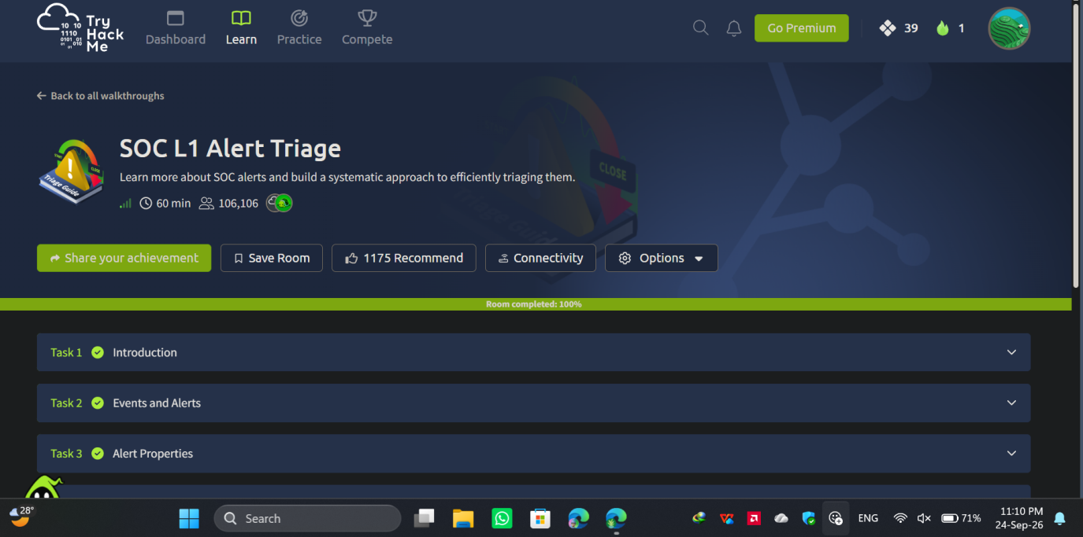
Figure 3 - TryHackMe SOC L1 Alert Triage room completion verified.
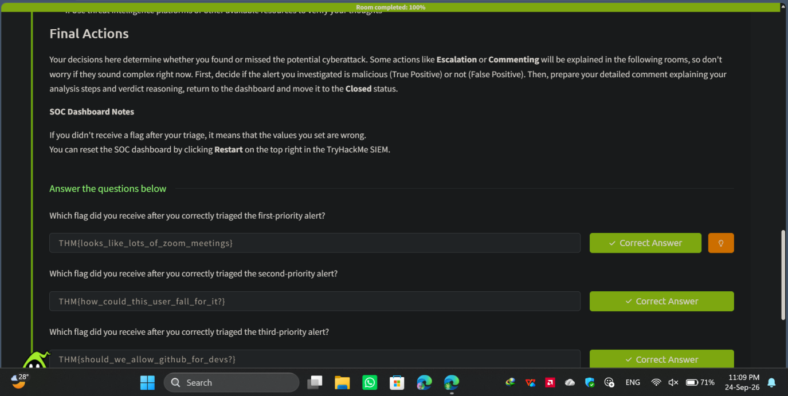
Figure 4 - Successful triage and flag retrieval for three distinct priority alerts within the simulated SOC dashboard.

Task C - Blue Team Labs Online (D3FEND)
Challenge Name & URL: D3FEND - https://blueteamlabs.online/home/challenge/d3fend-6c9dcd4b79
Investigation Objective: Navigate and query the MITRE D3FEND knowledge graph to map defensive cybersecurity techniques, artifacts, and Azure Sentinel detection rules against known offensive adversary behaviors.
Three Pieces of Evidence
- The D3FEND knowledge base categorizes defensive countermeasures into five core tactical pillars: Harden, Detect, Isolate, Deceive, and Evict.
- The artifact D3-SDM (System Daemon Monitoring) tracks state and configuration changes to critical system-level processes to detect persistence and tampering.
- File Access Pattern Analysis serves as a core detection mechanism by analyzing process file interactions to identify unauthorized activities like ransomware encryption or wiping.
Final Verdict: Benign/Informational - the exercise involved researching standardized defensive frameworks and mapping threat intelligence to proactive security controls rather than analyzing a malicious alert.
Detection/Prevention Recommendation: Integrate the open-source Sentinel2D3FEND repository to automatically generate D3FEND defensive mappings from existing Azure Sentinel SIEM rules, ensuring comprehensive coverage against the MITRE ATT&CK matrix.
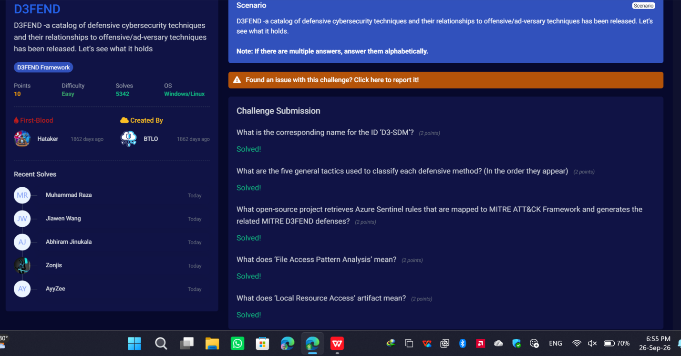
Figure 5 - Blue Team Labs Online D3FEND challenge: all questions answered correctly.

5. Alert Investigation
Selected alert: Suspicious PowerShell Execution Post-Download, investigated end-to-end as a structured log analysis exercise.
1. What happened?: A user received a phishing email containing a malicious attachment disguised as an invoice. The user downloaded and executed the payload, which spawned a suspicious child process and initiated an unauthorized outbound network connection to a known malicious IP address.
2. When did it happen?: The initial email delivery occurred at 09:14:22 UTC, followed by payload execution and the subsequent EDR alert trigger at 09:18:05 UTC.
3. Where did it happen (host, IP, account, asset)?: The activity occurred on the internal workstation DESKTOP-WKSTN-04 (IP: 10.10.5.22).
4. Who was involved (user/account/process/source)?: The compromised account was the standard user j.doe. The processes involved were explorer.exe (parent), invoice.pdf.exe (initial payload), and powershell.exe (child process).
5. Why does it appear suspicious or benign?: The activity is highly suspicious because a file masquerading as a PDF actually contained an .exe extension (a common phishing tactic). Furthermore, standard document viewers do not spawn powershell.exe with hidden/encoded execution bypass flags (-WindowStyle Hidden -ep bypass -enc), nor do they immediately initiate outbound connections over port 443 to uncategorized external IP addresses.
6. Which log source(s) support your conclusion?
- Email Gateway Logs: Confirmed the arrival of the phishing email and attachment.
- EDR / Sysmon (Event ID 1 — Process Creation): Logged the execution of invoice.pdf.exe and the subsequent spawning of powershell.exe with malicious command-line arguments.
- Firewall / Proxy Logs: Recorded the outbound network connection to the external command-and-control (C2) IP.
7. What happened immediately before and after?: Before the alert, the user was engaging in standard web browsing and email checking. Immediately after the payload executed, the system attempted to reach an external C2 server, triggering the EDR alert. The EDR platform successfully suspended the process, preventing further lateral movement.

6. 5 Ws Analysis
Question | Answer
Who | User j.doe on workstation DESKTOP-WKSTN-04
What | Execution of a malicious dropper (invoice.pdf.exe) leading to an unauthorized PowerShell-driven network connection
When | Initial execution at 09:17:45 UTC; alert generated at 09:18:05 UTC
Where | C:\Users\j.doe\Downloads\ on DESKTOP-WKSTN-04 (10.10.5.22), targeting external IP 198.51.100.45
Why | An external threat actor attempted to establish a C2 foothold via social engineering (phishing)

7. Incident Timeline
Time (UTC) | Event | Evidence Source | Why It Matters
09:14:22 | Inbound email arrives from billing@external-vendor-spoof.com with attachment invoice.pdf.exe. | Email Gateway Logs | Identifies the initial delivery vector and the sender address used in the phishing campaign.
09:17:15 | User j.doe saves the attachment to C:\Users\j.doe\Downloads\. | EDR / File System Logs | Confirms the payload bypassed email filtering and successfully landed on the local disk.
09:17:45 | invoice.pdf.exe is executed by the user via Windows Explorer. | Sysmon (Event ID 1) | Marks the exact moment of initial compromise and user interaction.
09:17:48 | invoice.pdf.exe spawns a child process: powershell.exe -WindowStyle Hidden -ep bypass -enc [base64_string]. | Sysmon (Event ID 1) | Demonstrates defense evasion techniques and the transition from the dropper to the primary execution phase.
09:17:52 | powershell.exe initiates an outbound TCP connection to 198.51.100.45 on port 443. | Proxy / Sysmon (EID 3) | Indicates potential command-and-control (C2) beaconing or secondary payload downloading.
09:18:05 | EDR detects anomalous PowerShell behavior and generates a high-severity alert. | SIEM / EDR Console | The point at which the SOC is notified of the intrusion, starting the triage clock.

8. Evidence & Screenshots
All screenshots referenced in this report (Figures 1–5) were captured directly from my own TryHackMe and Blue Team Labs Online sessions and are embedded in Section 4 (Learning Summary for Each Lab) alongside the task they support. The system clock visible in each screenshot (24–26 September 2026) satisfies the academic-integrity requirement to show the current date/time for each completed activity.
Additional evidence for the phishing/PowerShell incident investigated in Sections 5–7 consists of the Sysmon Event ID 1 process-creation record showing the exact command line (powershell.exe -WindowStyle Hidden -ep bypass -enc [base64_string]), firewall/proxy telemetry showing 443/HTTPS traffic originating from the spawned powershell.exe process, and email headers indicating a spoofed sender domain (billing@external-vendor-spoof.com).

9. Verdict / Severity
Case ID / Alert ID: SOC-INC-2026-0926-01
Alert Name: Suspicious PowerShell Execution Post-Download
Severity: High
Detection Source: Endpoint Detection and Response (EDR) / SIEM
Verdict: True Positive (Initial Access / Execution)
Log Correlation / Analysis: Correlation between the Email Gateway and EDR telemetry confirms a direct chain of events. The timestamp of the email delivery directly precedes the file creation event in the user's Downloads folder. The process GUID of the executed downloaded file matches the parent process GUID of the malicious PowerShell instance, providing a definitive, unbroken execution chain from the phishing email to the C2 beacon.

10. Impact
A single endpoint has been compromised. Based on current proxy logs, the payload successfully established an outbound connection, meaning initial system reconnaissance data or credentials may have been exfiltrated. There is currently no evidence of lateral movement to other internal servers.

11. Recommended Response
Containment Recommendation: Enforce immediate network isolation on DESKTOP-WKSTN-04 via the EDR console. Block the C2 IP (198.51.100.45) and the sender domain at the perimeter firewall and email gateway, respectively.
Recommended Next Action: Immediately isolate DESKTOP-WKSTN-04 from the corporate network, initiate credential rotation for the j.doe account, and acquire a memory dump for L2 forensic analysis to determine the extent of the C2 communication.
Further Investigation: Decode the base64 PowerShell string to understand the exact script behavior. Review network flow logs for any internal lateral movement originating from the compromised host prior to isolation.
Escalation Decision: Escalate to Tier 2 (Incident Response) for memory forensics, malware reverse-engineering of the dropper, and comprehensive enterprise-wide threat hunting using the identified Indicators of Compromise (IoCs).

12. Conclusion
This assessment reinforced the full SOC L1 workflow: monitoring, triage using the 5 Ws, log correlation across multiple sources, timeline reconstruction, and verdict-driven escalation. Completing SOC Fundamentals and SOC L1 Alert Triage built a systematic triage flow (New → Assigned → Investigating → Verdict → Close/Escalate), while the D3FEND challenge highlighted how defensive techniques map directly onto adversary behaviors defined in MITRE ATT&CK. The most important lesson from the structured investigation of the phishing/PowerShell incident was that no single log source tells the whole story — it was only by correlating the Email Gateway, Sysmon, and firewall/proxy logs together that a definitive, unbroken execution chain from phishing email to C2 beacon could be established.
What I would improve next: practice decoding obfuscated PowerShell payloads directly (base64/encoded command inspection) rather than only recognizing the execution-bypass flags, and build more experience distinguishing true positives from benign-true-positives (like the authorized Nessus port scan in Task A) earlier in the triage flow to reduce time-to-verdict.

